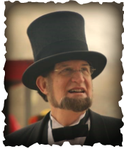
Visit With Abe

Abraham Lincoln • Presented by Robert Brugler
Life-Member, the Association of Lincoln Presenters

886 Middlebury Dr. N. • Worthington, OH 43085

Cell 614-312-7461 Fax 614-430-9008

Email VisitWithAbe@gmail.com Website www.VisitWithAbe.com

CONTRACT AND INFORMATION WORKSHEET

PLEASE COMPLETE AS SOON AS POSSIBLE. Thank you.

Today’s Date _______________ Presentation Date & Time __________________________________
Group/Organization ______________________________ How many people are expected? _______
Main audience (Please check) ___Adults ___High School ___Middle School ___Elementary
Address _________________________________________________________________________
City __________________________________________________State______Zip______________
Contact person ___________________________ E-mail Address ____________________________
Phone _________________________________ Cell phone _______________________________
Which of Robert’s Presentations are of interest to your group? Please see www.VisitWithAbe.com by clicking on the Presentation link.
_______________________________________________________________________________
How long would you like his presentation? ____________________________________________
Are you interested in a Question & Answer session after the presentation? ____ Yes ____ No

Should Robert do a meet and greet with the audience? ____ Yes ____ No ____ Both

Will there be a Sound System? _____ Yes _____ No
Is there a Lapel Mic available? _____ Yes _____ No
A press release is available at www.VisitWithAbe.com at the Contract & Information link on my home page and PHOTOS may be found at the Slide Show link
Directions to the building/location where Robert will present. _________________________________
_______________________________________________________________________________
_______________________________________________________________________________

Where do I park & what door do I enter? _______________________________________________
_______________________________________________________________________________
Knowing my audience beforehand allows me to adapt my presentation to their interest. What other information may be useful?

_______________________________________________________________________________

_______________________________________________________________________________

______________________________________________________________________________
In order to thank those who recommend me, please tell me how did you hear about my Lincoln Presentation?
_______________________________________________________________________________

_______________________________________________________________________________
Note: STILL PHOTOS may be taken of Mr. Brugler, even during his presentation, but please, no VIDEO OR
SOUND RECORDINGS unless preauthorized.

Honorarium: Please make checks payable to Robert Brugler
Payment is appreciated on date of presentation unless otherwise arranged.

PLEASE CHECK THAT THE ABOVE INFORMATION IS CORRECT, SIGN BELOW AND RETURN VIA MAIL OR EMAIL.

My agreement to be at your event will not be considered complete until
I receive this signed contract by return mail or by email attachment

Signature __________________________________________________________ Date _________
Date Received (Robert will complete) ___________________
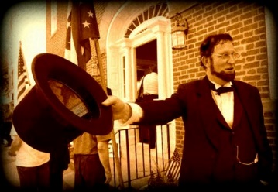
I am much obliged for your interest and assistance.

Robert Brugler

