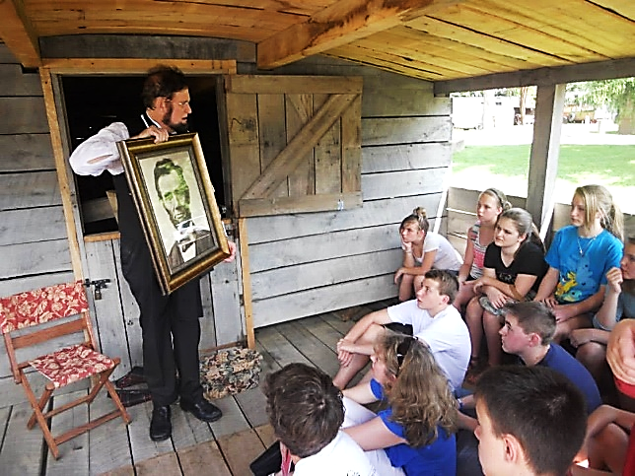
VisitWithAbe.com

Robert has presented Abraham Lincoln at
-Gettysburg, PA
-Washington, DC
-The Ohio Statehouse
-The Ohio History Center
-The Columbus Metropolitan Libraries
-The homes of Pres. Grant, Hayes & Garfield

Mr. Brugler presents an educational, enlightening, and informative look at the life of the 16th President.
Civil War Days, Marietta, OH
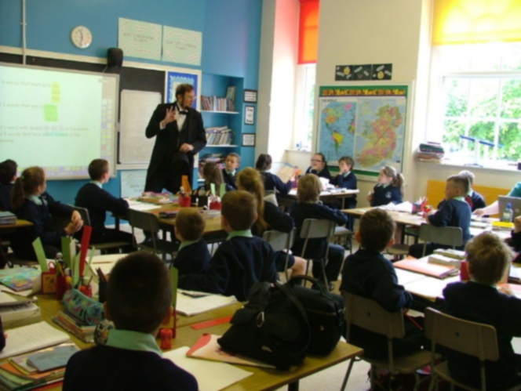
Hope Taft, Former First Lady of Ohio
﻿“Bob is wonderful as an interpreter in teaching and informing his audience as well as engaging and entertaining adults and children.”
Gail Martin, The Marion County Historical Society
"Robert is totally engaging and makes you feel you are having a conversation with old Honest Abe himself.”
Dr. Rick Weil, On President Reagan's Staff
“We so enjoyed the humor and knowledge that you so easily share. It is an absolute pleasure and honor to listen and learn from you."
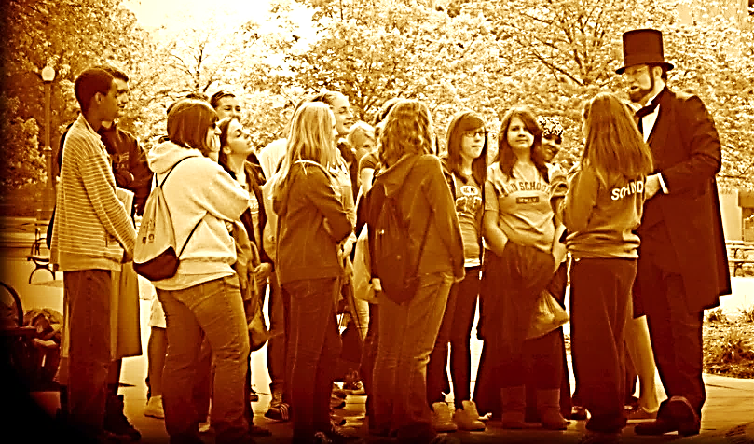
Presenting in Northern Ireland
Many thanks for your consideration,
Robert Brugler
886 Middlebury Dr. N.
Worthington, OH 43085
Cell 614-312-7461
VisitWithAbe@gmail.com
- I am also available for other venues: meetings, lunches, churches, historic societies, senior citizen centers, museums, libraries, civil war reenactments. Please see my webpage VisitWithAbe.com for more information.

At the Ohio Statehouse

Nothing Better Prepares Today’s Students to Face the Future

Than the Study of the Past!

"VISIT WITH ABE” IS A PROGRAM THAT:

- Allows your students to experience "History" first hand!
- Challenges students to learn more, seek more, & read more!
- Gives students the opportunity to ask questions and receive answers from President Lincoln himself!
- Is appropriate for schools and other educational settings and events.
- Can be customized for all audiences.
- Addresses such issues as peer pressure, self-esteem, & character development.
- Also, expresses laughter, love, humor, forgiveness, morals, determination, and above all, a sense of patriotism & pride!

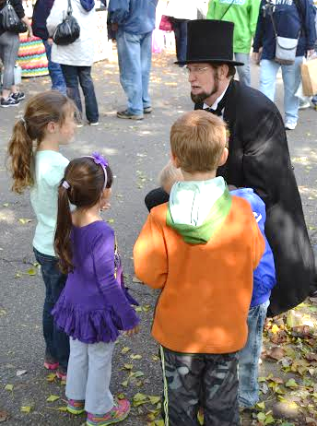
Children Presentations can be modified for any age group.
1. Growing up to be President
2. Lessons learned from Abe Lincoln
3. Abe Lincoln & his kids.
4. Life in the Executive Mansion (White House)
5. Ask Abe Lincoln (or questions often asked can be supplied)
1 presentation | $150
2 presentations (same day) | $200
3 presentations (same day) | $250
All day appearance; up to 5 presentations | $325

All fees include travel within 25 miles of my home in Worthington, OH. Over 25 miles a charge of $.50 per mile is added. Overnight events are negotiable.

Because I was a teacher for 35 years, I can adjust presentations to cover the curriculum from each class level.

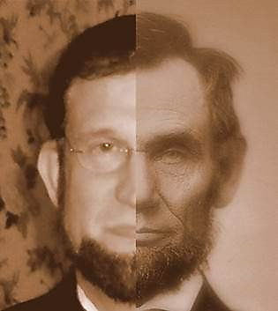
Some schools request President Lincoln to come every year.

Ways to use "Visit with Abe” at Your School:

● School Assemblies
● Open House
● P.T.A. Programs
● After School Programs
● Festivals & Special Events

Reference from a teacher where I spoke before they went to Washinton, D.C. & Gettysburg.
Susan Stovcik stovciks@parmacityschools.org 440-667-9071

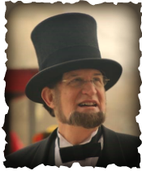
Visit With Abe

Abraham Lincoln • Presented by Robert Brugler
Life-Member, the Association of Lincoln Presenters

886 Middlebury Dr. N. • Worthington, OH 43085

Cell 614-312-7461 Fax 614-430-9008

Email VisitWithAbe@gmail.com Website www.VisitWithAbe.com

CONTRACT AND INFORMATION WORKSHEET

PLEASE COMPLETE AS SOON AS POSSIBLE. Thank you.

Today’s Date _______________ Presentation Date & Time __________________________________
Group/Organization ______________________________ How many people are expected? _______
Main audience (Please check) ___Adults ___High School ___Middle School ___Elementary
Address _________________________________________________________________________
City __________________________________________________State______Zip______________
Contact person ___________________________ E-mail Address ____________________________
Phone _________________________________ Cell phone _______________________________
Which of Robert’s Presentations are of interest to your group? Please see www.VisitWithAbe.com by clicking on the Presentation link.
_______________________________________________________________________________
How long would you like his presentation? ____________________________________________
Are you interested in a Question & Answer session after the presentation? ____ Yes ____ No

Should Robert do a meet and greet with the audience? ____ Yes ____ No ____ Both

Will there be a Sound System? _____ Yes _____ No
Is there a Lapel Mic available? _____ Yes _____ No
A press release is available at www.VisitWithAbe.com at the Contract & Information link on my home page and PHOTOS may be found at the Slide Show link
Directions to the building/location where Robert will present. _________________________________
_______________________________________________________________________________
_______________________________________________________________________________
Where do I park & what door do I enter? _______________________________________________
_______________________________________________________________________________
Knowing my audience beforehand allows me to adapt my presentation to their interest. What other information may be useful?

_______________________________________________________________________________

_______________________________________________________________________________

______________________________________________________________________________
In order to thank those who recommend me, please tell me how did you hear about my Lincoln Presentation?
_______________________________________________________________________________

_______________________________________________________________________________
Note: STILL PHOTOS may be taken of Mr. Brugler, even during his presentation, but please, no VIDEO OR
SOUND RECORDINGS unless preauthorized.

Honorarium: Please make checks payable to Robert Brugler
Payment is appreciated on date of presentation unless otherwise arranged.

PLEASE CHECK THAT THE ABOVE INFORMATION IS CORRECT, SIGN BELOW AND RETURN VIA MAIL OR EMAIL.

My agreement to be at your event will not be considered complete until
I receive this signed contract by return mail or by email attachment

Signature __________________________________________________________ Date _________
Date Received (Robert will complete) ___________________
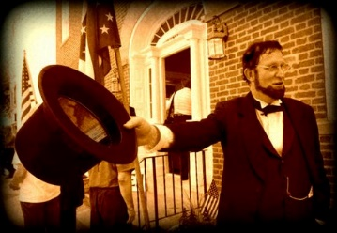
I am much obliged for your interest and assistance.

Robert Brugler

